**Chapter 9, Section 44: The Emergency Republic, 1792 – 1795: The TERROR**

* National Convention: Controlled by Jacobins
* Girondists
* “The Mountain” or Montagnards

**Versus**

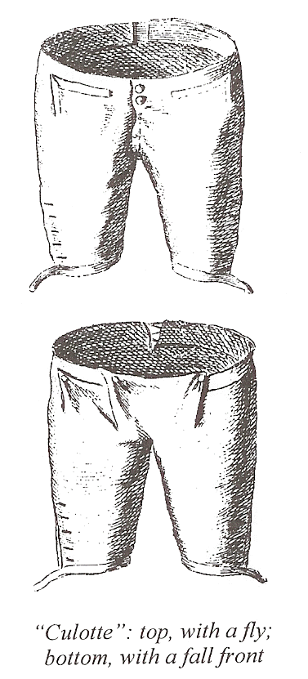**Politics of Parisian Sans-Culottes**

* Fear Convention too moderate
* Want direct democracy locally, overthrow Convention if needed
* Mountain favors; Girondins believe anarchic
* Denounce king
* King on Trial for treason - January 15, 1792:
* *What was the vote for his death?*

**April 1793 -Background to the Terror**

Politics of Parisian sans-culottes:

* *Who was the one who dealt with these threats?*

*Create a biographical sketch of* ***Robespierre*** *and his background and values*

**The Program of the Convention, 1793-1794: The Terror**

**Levee en Masse**: (calling on all able-bodied men to rally to the colors)

*Why did they recruit scientists?*

* Committee of Public Safety Accomplished or Intended to Do…
* June 1793: New Constitution establishes __________________; however, it is suspended until the __________.
* 1794: Explain the question of slavery & where it affected.
* *What was the festival of the Supreme Being?*

Meanwhile…

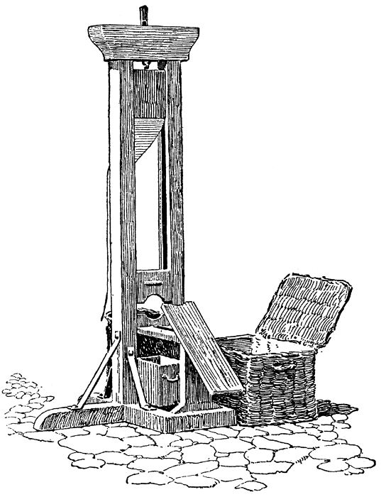

*Guillotine:*

*How might the guillotine be an enlightened form of execution?*

* *Who are the victims of the “Reign of Terror”?*

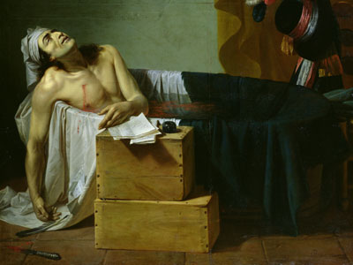

Murder of Jean Paul Marat:

* **The Fall of Robespierre:**

Effects of the Fall of Robespierre:

* **End of the National Convention**
  + *After Robespierre’s execution, National Convention leaders __________________________________________________*
  + *Convention remains in place until the new structure is created and new members elected*
  + *This will become the 5th and final stage…****______________________***